D214 Executive Summary
Justin Jordan
Western Governors University
MDSA
D214 Capstone Task 3: Presentation of Findings
September 20, 2026

Problem Statement and Hypothesis:
Research Question: Can we forecast the future stock price using time series analysis based on historical stock data?
Null hypothesis: The future stock price cannot be predicted with 80% accuracy
Alternate Hypothesis: The future stock price can be predicted with 80% accuracy

The stock market plays an important role in the economy by allowing businesses to raise money, help people grow wealth and acts as an indicator to the overall health of the economy. The movement or health of the stock market can impact a company in a variety of ways. The higher the shares are priced, the more a company is worth in the market. The lower the shares are priced, the less a company is worth. Stock prices fluctuate from day today making stock price prediction important to a company shareholders as nobody invests to lose money. The objective is to analyze the historical stock price and identify any patterns or trends to develop a model that can accurately predict the future stock price.

This study will utilize an ARIMA model to forecast future Microsoft stock prices by analyzing the historical time series data and identifying patterns or trends within the time series. By examining the differences between past and future values, ARIMA assists in predicting trends in financial markets, such as stock prices or company earnings, based on historical performances. This model leverages autoregressive properties, making it effective for short-term forecasting where past data significantly influences future outcomes (Hayes, 2026).

Data Analysis Process:

The Microsoft Stock Price History data will be downloaded from Kaggle and is one CSV file containing 6 columns and 10,094 rows before cleaning. Historical data is needed for time series and ARIMA to forecast the future stock price. The data set includes the following variables of date, close, high, low, open and volume between March 26th 1986 and April 20th 2026. The data set will then be loaded into a Jupyter Notebook where Python will be used to explore and clean the data. The data set will be loaded into a data frame using Pandas where it will be checked for null values and formatting differences. Since the original data begins in 1986, we run the risk of overfitting our historical data which may result in less accurate predictions (Indicio Technologies, 2024). As part of the data cleaning and preparation process to help prevent overfitting, only the last 10 years of data will be used for the model. The new data frame will contain the last 10 years of data with the variables of Date and Close as those will be the only columns used in the model. The graph below is a visualization of the Close Price over the last 10 years of data. The graph shows an upward trend which may indicate a lack of stationarity. To check for this, we will use an Augmented Dickey-Fuller test to fully evaluate for stationarity as part of the analysis.

Before the ARIMA model can be built, the data frame must be checked for stationarity using an Augmented Dickey-Fuller test. After performing the ADF test, the data was not stationary. The Close column was passed thru the function and returned a P-value of .86, which is greater than the .05 value. Since the data is not stationary, we will need to diff the data to make it stationary. After differencing the data, the time series data is now stationary and ready for forecasting. Below is a graph of the rolling mean and standard deviation of the data.

In order to build and train an ARIMA model, the prepared data will need to be split into a train and test set. The train and test set was split with a 70/30 split. This means 70% of the prepared data was used for train and 30% was used for test. Below is a graph visualizing the splitting of the train and test sets.

Next, the data will be evaluated for stationarity. The plot below is a full decomposed time series. It shows an upward trend within that data. It also shows the lack seasonality of the data. The residuals show they have a constant mean centered at zero.

The power spectral density plot below shows the time and variance between the previous and current time periods or covariance. It shows a decent amount of overall variability.

Below is the decomposed time series of the differenced data showing the data is now stationary as well as a graph of the rolling mean and standard deviation. Another ADF test was performed as well to confirm stationarity of the data.

The auto_arima function will be used to automatically find the best parameters for our ARIMA model. The auto_arima function automates the process of fitting different models and deciding which one is best. In Time Series Analysis, a correct model should yield the highest Log-Likelihood and requires the lowest AIC. The AIC and BIC of a model depend on the log-likelihood, to be more precise AIC and BIC uses Log-Likelihood in their formula. This would indirectly imply that the log-likelihood is high therefore this method cycles through the model with varying orders and specifications and out of those returns the one with the lowest (Prasad, 2021). We will also run a couple manual ARIMA's to verify the order of p,d,q from the auto_arima. Below is the SARIMAX results of the auto_arima function.

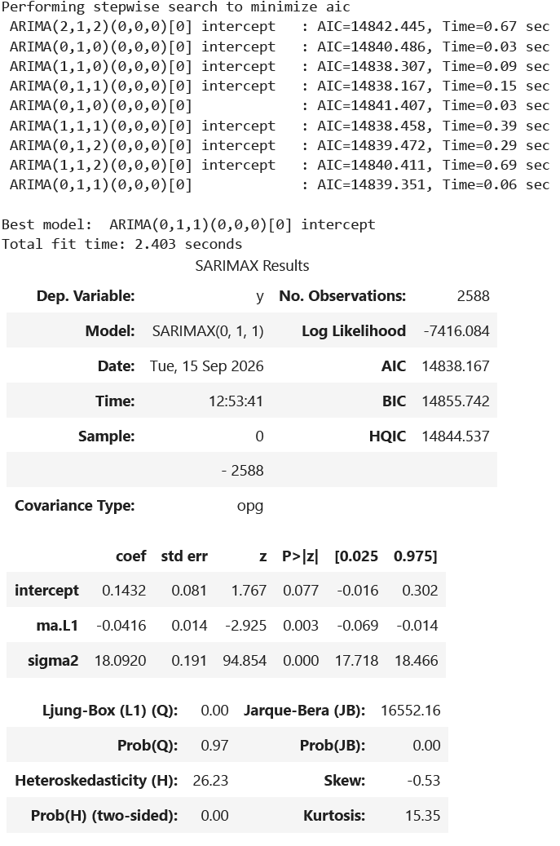

We can now run our forecast with the parameters for auto_arima. MAPE will also be calculated so we can determine the outcome of our hypothesis. Below are the graphs visualizing the forecast as well as the MAPE calculation.

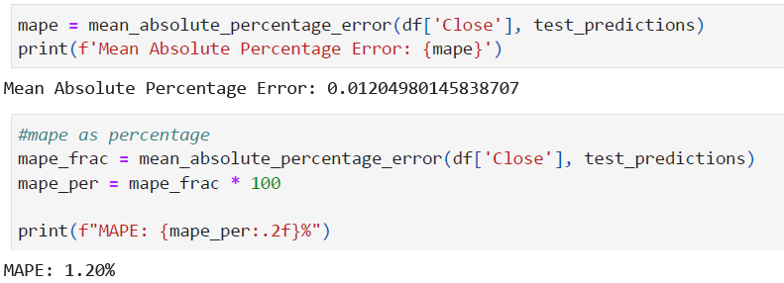

Summary of Analysis Findings:

By utilizing an ARIMA model on the historical stock price data of Microsoft, we were able to accurately forecast future closing prices of Microsoft stock. The observed range for the model was between 2016-01 & 2026-04, forecasting a range of 6 months in the future. Investors and shareholders can use the information to make informed decisions on future close prices based on historical performance.
The results of the error metric, Mean Absolute Percentage Error or MAPE, indicate the model predicts future close prices with 98.8% accuracy. With an accuracy of 98.8%, we can reject the null hypothesis of our research question and accept the alternate hypothesis of "The future stock price can be predicted with 80% accuracy."
The diagnostic_plots() function generates plots about the model performance. Below are the plots generated from the function. The top left is a standardized residual for R plot. The plot does not show any patterns. However, there are volatility spikes after index 1000, with a larger negative spike near index 2500indicating the model is not capturing volatility shifts. The top right plot is a histogram with KDE. The KDE curve is more narrow and taller than the N(0,1) curve which indicates an excess of values near zero. The bottom left plot, is a normal q-q plot. The values along the red line stray at both ends. The downward curve on the far left along with the upward curve on the far right confirm the presence of outliers. The bottom right plot is a correlogram. This shows the residuals behave like white noise, meaning no significant lag patterns remain. Any correlations for lag greater than zero are insignificant.

Limitations of Techniques and Tools:

A limitation of a publically available dataset is it is limited by the accuracy and completeness of information made publically available.
Limitations in regards to specific tools, Jupyter Notebooks in VSCode is that sometimes the base environment being used for the kernel can mess up and not start (Minhas, 2025). The Pandas library can be challenging for beginners to understand and fully utilize all of the features it has to offer. Matplotlib, the visualizations created are static. Dashboards and interactive reports have become the norm in many fields, making static charts feel outdated (Loewen, 2025).
Limitations in regards to specific techniques, an ARIMA model is not built for long-term forecasting (Hayes, 2026). The auto_arima function, you never really get to see how well the other models perform since it gives you the best option. Another limitation of the analysis of stock price forecasting is that ARIMA only looks at historical data. Stock prices are often influenced by external factors such as economic shifts, market panic and company reports. People are unpredictable. Since people oftentimes influence the stock market, it makes it difficult to forecast future prices on historical data alone.

Summary of Proposed Actions:

Based on the findings of this project, it is recommended that the model can be used as a tool by investors and shareholders to help make informed decisions on future stock close prices of Microsoft. With that being said, based on the limitation stated above, the model should not be the only information used by investors and shareholders. It should be combined with other analysis tools to create a clearer picture of the stock’s performance.
The following are recommendations for future study.
- Model improvement. The current models serves as an excellent baseline to build upon. It is recommended to change some of the parameters of the model such as the observed range and the forecasting range to see if there are any improvements. Shortening both would be the next step, then compare the results of each. It would also be beneficial to try different splits in the test and training data. The current model uses a 70/30 split.
- Explore alternative models. Due to the limitations of an ARIMA model, it would be beneficial to explore alternative models such as Long Short-Term Memory or LSTM. LSTMs overcome these limitations by learning long-term relationships and automatically discard useless short-term market noise. They excel at mapping the complex, non-linear trajectories that stock prices actually follow (B, 2025). Being able to capture the complex patterns of market data would be a valuable asset to both investors and shareholders alike.

Benefits of the Study:

The benefit of this study is a model was built that can accurately forecast the future stock close prices of Microsoft that can be used by investors and shareholders to help make informed investment decisions. Since the model is based off of historical stock data, it can be used to forecast the future close prices of other companies as well, not just Microsoft. The stock market plays an important role in the economy by allowing businesses to raise money, help people grow wealth and acts as an indicator to the overall health of the economy. The movement or health of the stock market can impact a company in a variety of ways. The higher the shares are priced, the more a company is worth in the market. The lower the shares are priced, the less a company is worth. Stock prices fluctuate from day today making stock price prediction important to a company shareholders as nobody invests to lose money. With that being said, based on the limitation stated above, the model should not be the only information used by investors and shareholders. It should be combined with other analysis tools to create a clearer picture of the stock’s performance.

Sources:
B, A. (2025, March 21). Predicting stock prices using lstms: A step-by-step guide to time series forecasting | by aditi B | medium. Medium. https://medium.com/@aditib259/predicting-stock-prices-using-lstms-time-series-forecasting-a-step-by-step-guide-a70ebb04bbb8

Hayes, A. (2026, July 17). Master Arima: Your guide to time series forecasting. Investopedia. https://www.investopedia.com/terms/a/autoregressive-integrated-moving-average-arima.asp

Indicio Technologies. (2024, September 30). Are you held back by outdated historical data in your forecasting? https://www.indicio.com/resources/blog/are-you-held-back-by-outdated-historical-data-in-your-forecasting

Loewen, J. (2025, October 24). Three important reasons why I’m tired of Matplotlib | Data Storytelling corner. Medium. https://medium.com/data-storytelling-corner/three-important-reasons-why-im-tired-of-matplotlib-6686683c67a6

Minhas, M. S. (2025, January 18). 10 reasons why I stopped using jupyter lab. Towards Data Science. https://towardsdatascience.com/10-reasons-why-i-stopped-using-jupyter-lab-498e958424ac/

Prasad, E. (2021, May 20). What is Auto-Arima?. Auto_arima, a routine from imsl… | by Eswara Prasad | featurepreneur | medium. Medium. https://medium.com/featurepreneur/what-is-auto-arima-b8025c6d732d

